

Date: February 16, 2004
From: Gil Vivanco, Schumacher / Electronics Equipment Solutions (EES) (760-929-6246)
Distribution: Domestic and International Sales Representatives, Customer Service (SEMC, CSO, Carlsbad), Field Service, OEM Group, PC/MC, Equipment Engineering, EES Management
End of Life Price Adjustment on Obsolete Product Lines

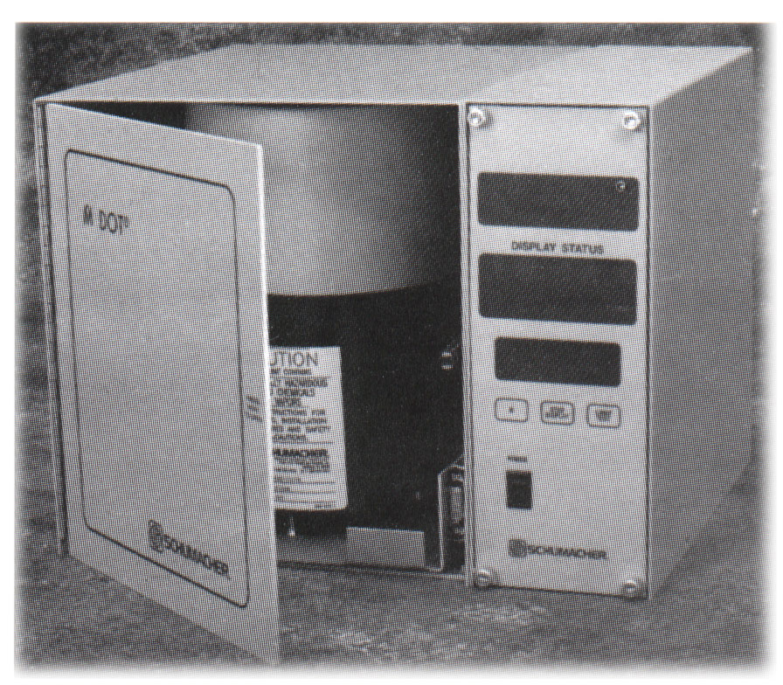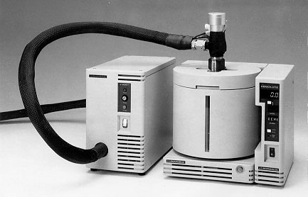 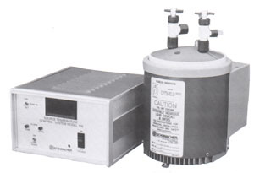 MDOT™ VMDOT™ STC/TCU

Atmospheric Mass Flow Control System Vacuum Mass Flow Delivery System Temperature Control System

As announced in October 2003, the Air Products (Schumacher) temperature and flow controllers (MDOT, VMDOT, STC and TCU) have been declared obsolete. In an effort to accommodate end of life demand for these obsolete product lines, Air Products (EES) will accept purchase orders for a limited time as indicated below.

The cost structure must be adjusted to reflect end of life factors such as obsolete components, low volume purchases, and loss of production efficiencies.

The existing installed base will be supported with service and repair for a period of five (5) years – until March 31, 2009. A quick Exchange Program will be established where customers can obtain credit for non-working units and pay for fully refurbished STC, TCU, MDOT and VMDOT systems. Details of the Exchange Program will be published by May 31, 2004.

If you have any questions or comments regarding this information, please contact us.
施宏昌Tony-shih shih1@airproducts.com phone:0935-514905
李啟祥Charles-Lee leec4@airproducts.com phone:0936-094098
賴政宏Peter-Lai laip@airproducts.com phone:0933-190023
Jerry-Chiang chiangj@airproducts.com phone:0933-311224
Company phone: 03-5722188

